

**Professional Practice**

**30202191**

**Course Tutor**

Dr. Ghassan Abuyaghi

**Assignment Title**

Planning an Orientation Event

**Submitted By:**

Khaled Masoud

Farouq Hassan

Ahmad Arqoub

Jana Abu-Rumman

Firas Tamimi

**Table of Contents**

**Part 1:**

**1.1** Introduction _____________________________________________________________ (4)

**1.2** About the Event _________________________________________________________ (4)

**1.3** Timetable ______________________________________________________________ (5)

**1.4** Contingencies and justifications of time allocated ______________________________ (6)

**1.5** Event Designs __________________________________________________________ (7)

**1.6** E-mails _______________________________________________________________ (10)

****************************************************************************

**Part 2:**

**2.1** Problem Solving ________________________________________________________ (11)

**2.2** Problem Solving Techniques ______________________________________________ (12)

**2.3** Problem Solving Methodologies ___________________________________________ (12)

**2.4** Evaluating different solutions for the problem ________________________________ (13)

**2.5** Referencing ___________________________________________________________ (14)

***********************************************************************

**Part 1**

**1.1: Introduction**

Ladies and Gentlemen,

We are delighted to welcome you to this special event. I am aware that all of us are here for a better life and a better future and today our event is all about the future.

We will provide you with a short description on today’s event. First, I would like to introduce our company to you.

We are an IT company named "Galaxy Training Center", we manage to develop and improve the IT systems and every related subject by supporting the skilled and talented ones, support the idea holders, no matter what the idea is because we are aware that every idea must be respected.

The event topic is one of the most interesting topics nowadays, the most wanted profession, "Cyber security ". This event will be a two-day event, the 1st day we will learn about certain topics in Cyber Security through lectures given by professionals, and the 2nd day will be a practical day.

Topics to be given: Cloud Security, Forensics and Network security.

The 2nd day, the practical day, we must show what skills we have learnt from the first day, and how it benefited us, we might have some competitions between the participants.

**1.2: About Our Event**

**Details:**

1. Date & Time: 2/2 – 4/2 ___________ starting at 10:30 AM
2. Location: Kempinski Hotel Ishtar Dead Sea
3. Attendance: 120 participants
4. Ticket Fee: 1050 jds & 1700 jds for duos

**Expected goals:**

1. Integrate Network Monitoring and Present Real-Time Solutions
2. Understand Software Design and Secure Practices
3. Impact Cybersecurity Risk in an Ethical, Social, and Professional Manner

**1.3: Timetable**

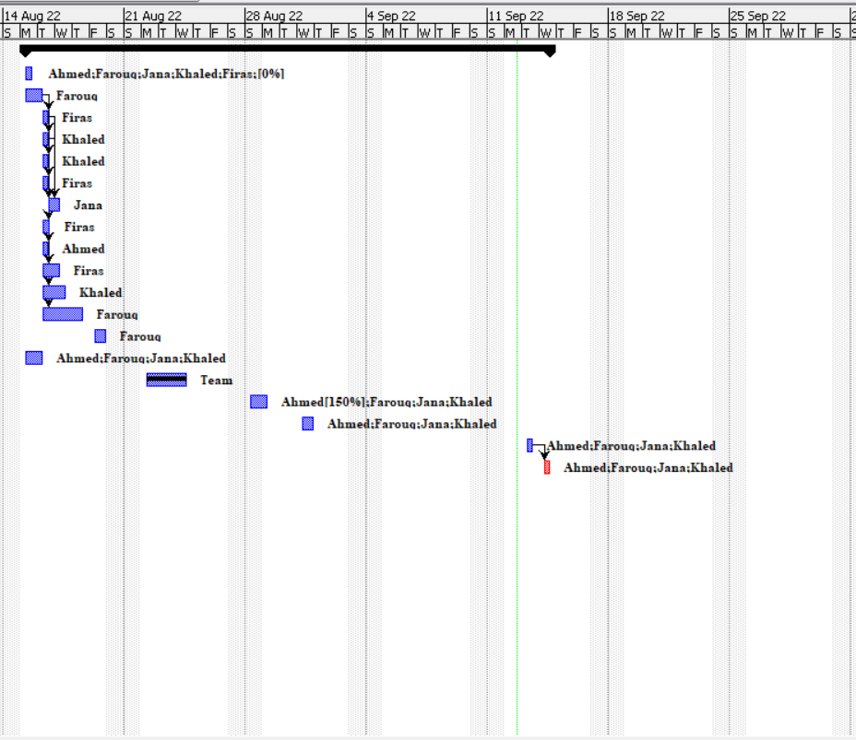

**1.4: Contingencies and justifications of time allocated**

**Plan B**

For the speakers if one of them have a problem and didn’t came we have another one to give the lecture.

More breakout rooms for the activities and for the workshop just in case something happened to them.

5 sponsors for the coffee break and the hotel prepare coffee if one of the sponsors didn’t come.

We take a place can fill by 150 people just in case there any person come.

We bring data show if the screen didn’t work.

Another laptop and other copy from the presentation if it didn’t work.

**1.5: Event Designs and Brochures**

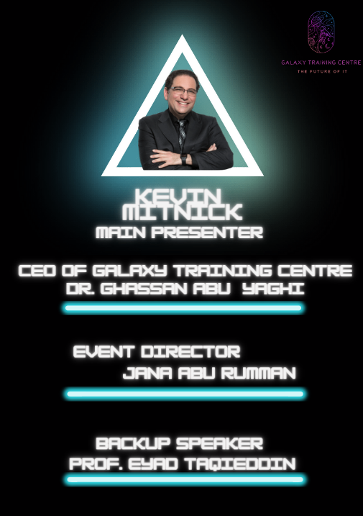

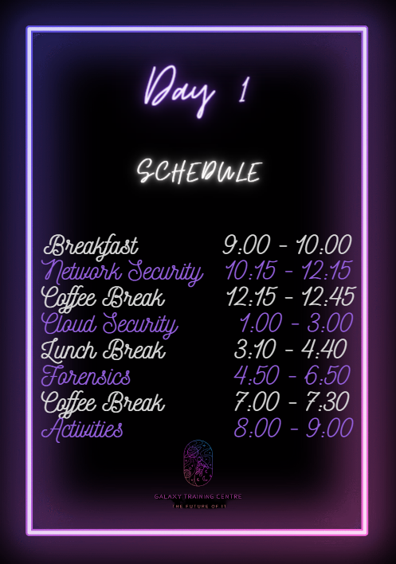

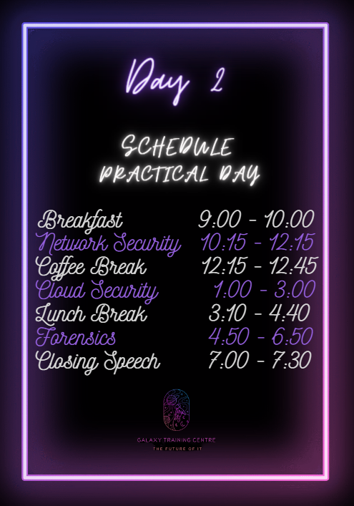

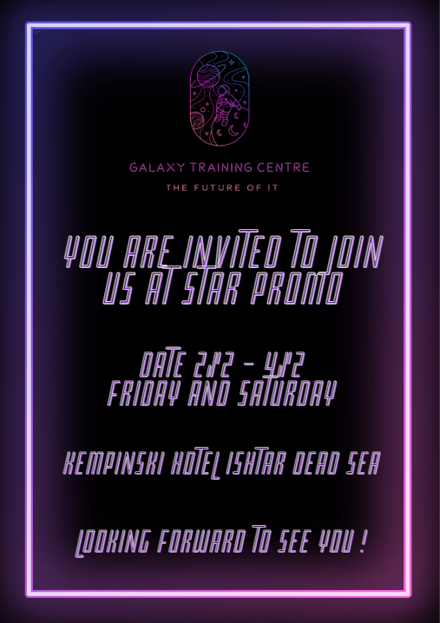

**1.6 :E-mails**

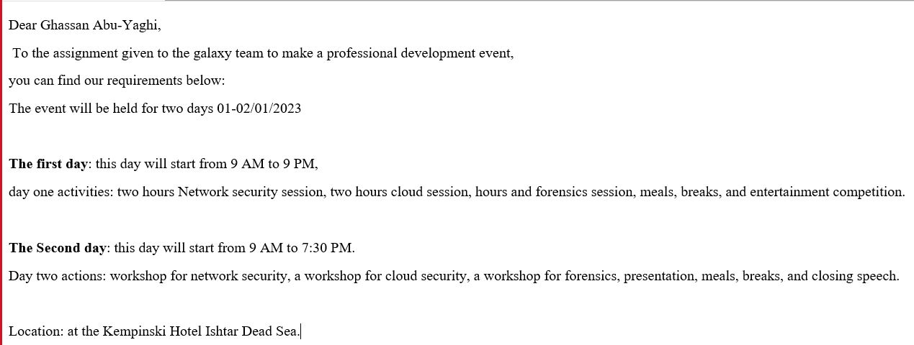

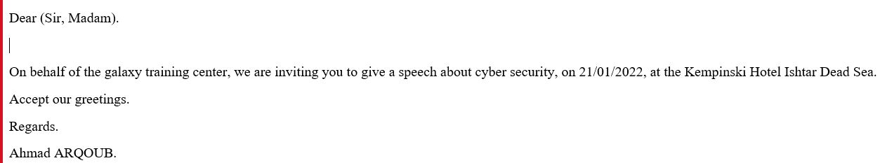



**Part 2**

**2.1: Problem Solving**

**2.1: The process of problem solving and its importance in planning and organizing of an event.**

Referring to our daily lives, we are always facing problems of all kinds, some of them are easy to handle and some involve deep thinking and hard work to overcome. So, what is a problem? A problem is the gap that separates us from our desired goal. When facing a problem, we try to solve the problem by any means necessary. That is our instinct.

Define problem solving?

Problem solving is a process of stating the problem and studying it to the find the most reasonable and suitable way to solve it using critical thinking.

The process of problem solving involves the use of several steps:

1. Identifying the problem

Defining the problem is the most important step during the process as it can help us understand the problem reaching the roots of it.

1. Gathering information

Start learning about the problem using different methods of information gathering such as documentation, interviews, questionnaires, and surveys.

1. Clarifying the problem

Make the problem as clear as possible. Focus on the main causes of the problem going through every cause until you reach the main cause. Start generating solutions.

1. Consider the possible solutions

List a number of solutions. Those solutions can be a result of critical thinking or thinking outside the box. Being realistic is also important when listing options.

1. Selecting the best option

Sorting the options or ranking them is the next step. This helps us chose the most reasonable and applicable solution.

1. Decide on a solution

Gather the opinions of your teammates on the best solution and start applying.

**2.2: Problem solving techniques**

Problem: We can’t sell more than 50 tickets while we need to sell 120 tickets.

After using the problem-solving steps, we were required to use to overcome this problem which are:

1. Defining the problem which allowed us to generate new ideas.
2. Determining the causes.
3. Identifying and prioritizing the alternative solution.
4. Implementing a solution.

While selling the event tickets we faced a financial issue which is not being able to sell more than 50 tickets. That is when we made an urgent meeting to discuss and solve the problem.

For solving the problem, we had to go through two problem solving methods:

1. Root Cause Analysis: First we analyze the problem. We as a team, having understood that our problem was not selling more than 50 tickets, asked ourselves what led us to this situation and how this problem will return to the company. Here we began to analyze the reasons that led us to this situation. We set it up and put a timeline on everything we did. We chose the biggest reason, which is that the price is too high for a lot of people, and we started working on fixing it. At this point, we've collected enough data, identified what our main problem is, and start by asking "why" after each mention of a reason that led us to this problem until we get to the root solution. After learning that our main problem was we found the radical solution, which is to sell tickets for 1700$ for any two people who meet and take a common room instead of 1500$ for one person. What we have left is to work on not returning to the same problems in the future.
2. OODA model: first, our team identified the problem and understand the situation that we were in and what we need to do some changes, so we wanted to reduce the price and see how much we need that, but at the same time not losing that big amount of profit, so we see if we take this way we won't lose as much we'll lose if we take another way, at the end we decided to put an offer that makes the ticket price 1700jd for the couples, we know it didn't make the same profit, but we reduced the number of losses as we could, so we started with this idea and made it real and put the offer in the emails and the brochures

**2.3: Methodologies**

Brainstorming:

Brainstorming was an important methodology that we used to solve our problems. As with any teamwork, we face some problems during work, and we solve them using brainstorming. We face the first problem after three meetings, we can’t find the correct time to make our meetings. Then we think about how we can solve it, and we collect the solutions. Then we chose Khaled’s idea which is that we can do our meetings after our professional practice lecture.

Hypothesis testing:

At first, we determined what the problem was (we can't sell more than 50 tickets), then we developed hypotheses and analyzed all of them, and we excluded the weak hypotheses and kept the strong ones, and in the end, it became clear to us that the strongest hypothesis is that the problem is the ticket price.

**2.4: Evaluate the different solutions for the problem and provide a logical reasoning for the solution used**

As with any problem, we came up with many solutions, then we choose the best one for our problem.

One of the solutions was to make a special offer for the invitees which was to reduce the ticket price for people who want to book a room with someone else, they can buy two tickets for 1700 JD Instead 1050 JD each. If was use this solution, our expected profit will be around 23000 JD to 44000 JD.

Another solution we came up with is to contact some famous social media influencers and ask them to promote for our event on their social media accounts. The event’s total cost should be 58000 JD. Using this method will cost us more than 58000 JD as we will be forced to pay the influencers and provide them with rooms to stay for the event.

Finally, we tried to contact the hotel and negotiate a better offer as we think that the price is a bit above the range. This option was out of our reach and the hotel did not accept our counteroffer.

After gathering opinion and calculating the end results of our solutions, we decided on solution number one as it was the safest option with guaranteed positive results.

**Referencing:**

Professional Practice Power Points on Team